UCANDAS for Android quick operation user manual
5 steps to use UCANDAS for Android to diagnose car

This software runs on Android 4.0 above tablets and phones with WIFI and 720P above screen resolution.

Step –by –step procedure:

Step 1: Download APP and install

Step 2:
Connect VDM to the car, go to ‘Settings’ to search WIFI and find the SSID is UCANDAS, connect it successfully, shown as below.

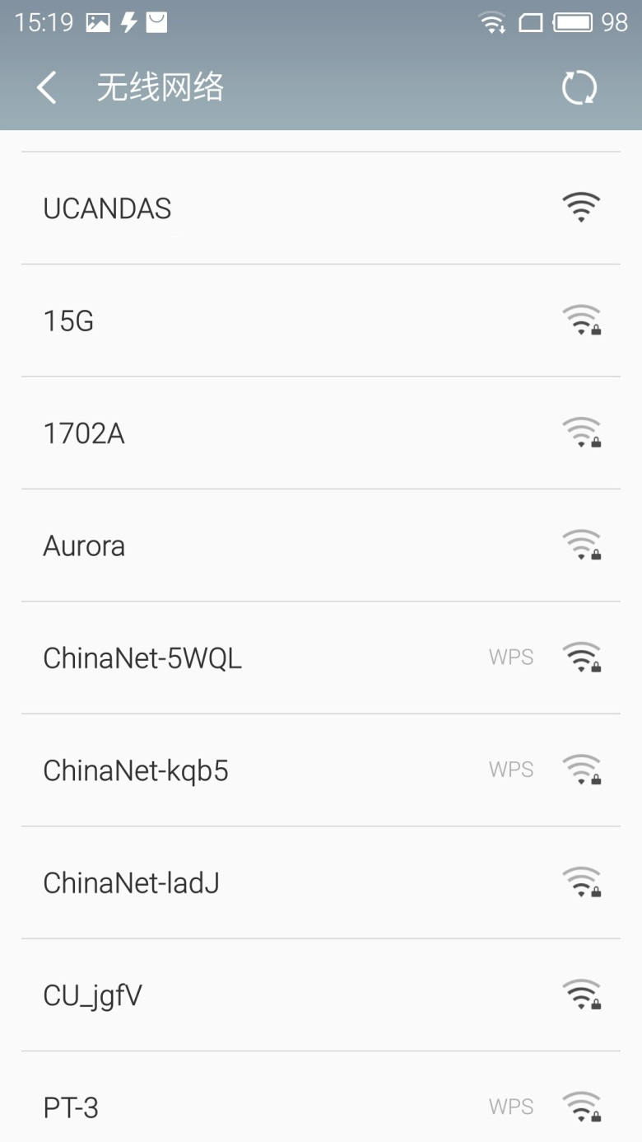

Step 3:
Run UCANDAS, click the icon ‘Register’, input your basic information.
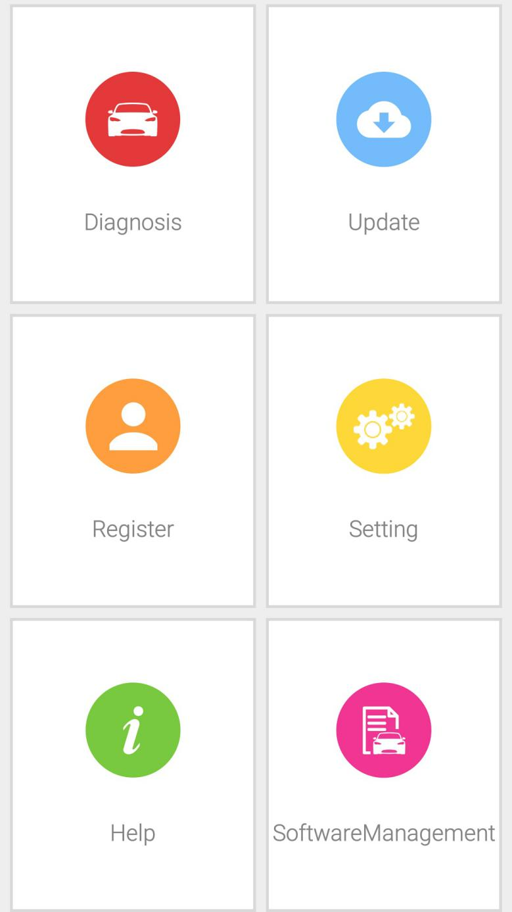
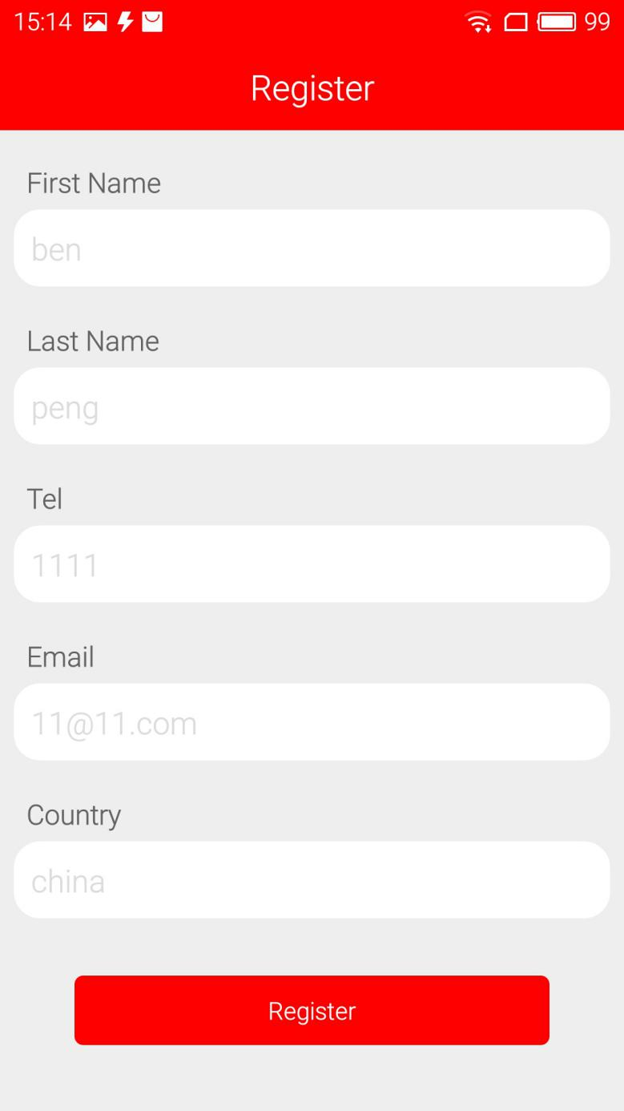
Please be informed: after register, the diagnostic program downloaded via the APP only runs with this VDM, not with other VDM.

Step 4:
Unplug VDM from the car and connect network connection, choose ‘Update’, then ‘Language’, download the diagnostic program you want shown as below.
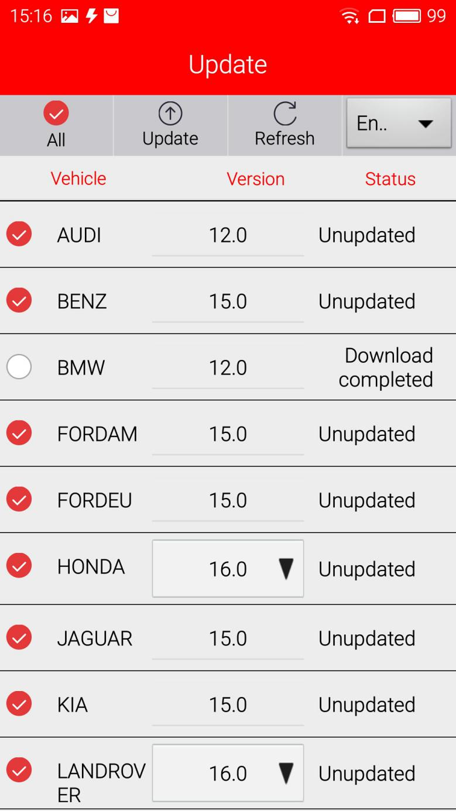
Step 5:
Now you are able to test your car.
